“IGNITE YOUR FUTURE”

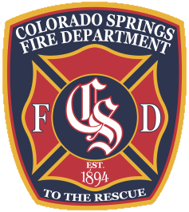

CSFD FIREFIGHTER HIRING PROCESS SMART BOOK

The mission of the Colorado Springs Fire Department is to provide fire, emergency and prevention services with professionalism, compassion, and excellence.

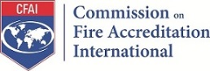
Internationally Accredited Agency
2018-2023

https://coloradosprings.gov/firejobs

31JAN2020
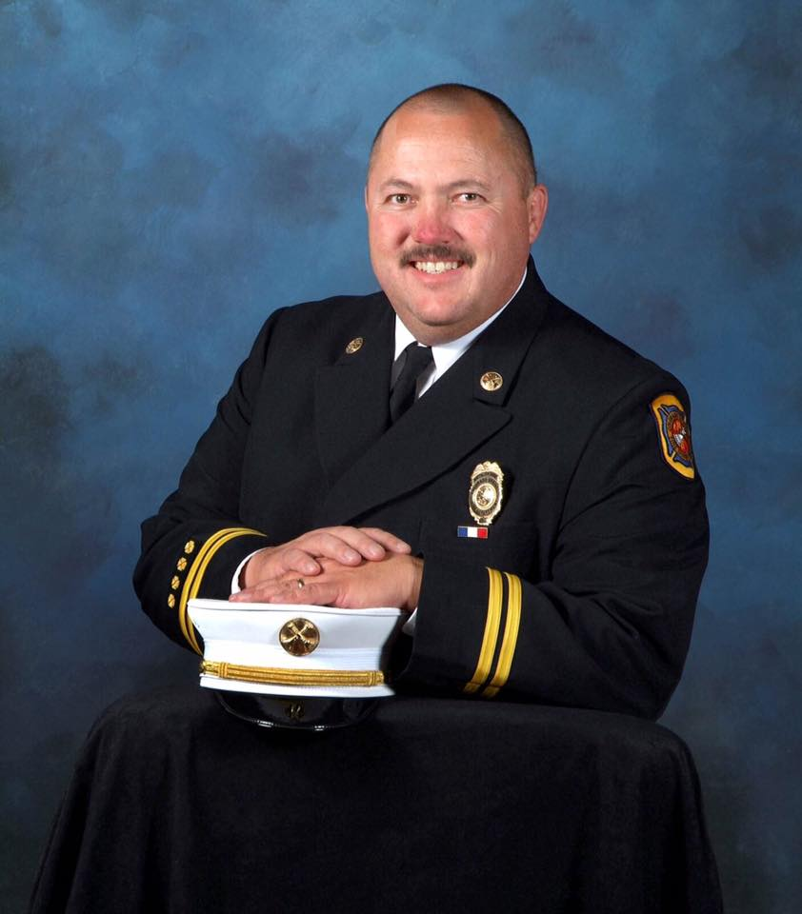

"Thank you for your interest in joining the noble and rewarding profession of firefighting. The Colorado Springs Fire Department enjoys a reputation of providing outstanding service to our community. I applaud you for your interest in joining the public safety community. I have served as a member of the CSFD for over 30 years and I am excited about our future." - Chief Ted Collas

CSFD MISSION STATEMENT

“The mission of the Colorado Springs Fire Department is to provide fire, emergency and prevention services with professionalism, compassion, and excellence”.

CSFD VALUES

Accountability
Courage
Honor
Professionalism
Service

CSFD STATISTICS
- City Council voted to organize paid fire department on February 12, 1894
- Colorado Springs has a population of approximately 659,000
- CSFD serves an area of approximately 200 square miles and provides coverage 24 hours a day, 365 days a year
- CSFD has over 450 uniformed firefighters across 3 different shifts
- CSFD responded to 70,000 alarms during 2019, 65% of which were medical emergencies
- CSFD resources include:
23 Fire Stations housing;
23 Engine Companies
11 Brush Trucks
6 Truck Companies
2 Heavy Brush Trucks
2 High Angle Rescue Companies
1 Heavy Rescue Team
1 Hazardous Materials Decontamination vehicle
1 Decontamination Trailer
3 Medical Squads
1 Air Supply Truck
1 Hose Tender

FIREFIGHTER DUTIES & SPECIALTIES
- Fire rescue / fire suppression / salvage and overhaul
- Emergency medical services (ALS & BLS)
- Wildland firefighting
- Heavy rescue operations
- High angle rescue operations
- Hazardous materials response / decontamination procedures
- Tactical enforcement unit (TEMS)
- Air 15 program (self-contained breathing apparatus)
- Disaster planning / training
- Maintenance of equipment and facilities
- After the fire program
- Continuing education and training

QUALITIES / CHARACTERISTICS OF A FIREFIGHTER
- Committed to excellence
- Professional
- Have integrity and a strong work ethic
- Likes helping people & values others
- Is community minded
- Likes working with tools and equipment
- Is a team player
- Able to work unsupervised
- Quick thinking
- Remains flexible in and can adapt to a changing work environment
- Is physically & mentally fit
- Likes adventure and excitement, but can remain calm in such situations
- Able to adapt to shift work

Colorado Springs Fire Department Sample Shift Calendar
JANUARY
Sun | Mon | Tue | Wed | Thu | Fri | Sat
1 A | 2 C | 3 A | 4 C | 5 B | 6 C | 7 B
8 A | 9 B | 10 A | 11 C | 12 A | 13 C | 14 B
15 C | 16 B | 17 A | 18 B | 19 A | 20 C | 21 A
22 C | 23 B | 24 C | 25 B | 26 A | 27 B | 28 A
29 C | 30 A | 31 C

Each Shift is for a 24hr period, which may include Station Training or Community events.

RELEVANT PREPARATORY COURSES
- Physical Fitness Training
- Physical education (aerobic and strength training)
- Health / biology / anatomy & physiology
- Basic mathematics
- Basic physics
- English (reading comprehension and writing)
- Computers
- Emergency Medical Technician training and certification available through Pikes Peak Community College
- Fire Science Technology courses available through Pikes Peak Community College
- Candidate Physical Ability Test training available through Pikes Peak Community College
- Interview techniques training available through Pikes Peak Community College
- CSFD Ride Along Program
- Volunteer work with local volunteer fire departments
- Explorer Program and Summer Heat

FIREFIGHTER CANDIDATE MINIMUM QUALIFICATIONS
(Subject to change)

The following minimum qualifications must be met to participate in the firefighter selection process:
- You must be at least 18 years of age by date of hire.
- You must have a high school diploma or GED certificate.
- You must have successfully completed the Candidate Physical Abilities Test (CPAT) no more than 12 months prior to the testing process.
- You must be in appropriate physical condition and meet medical standards as established by the City of Colorado Springs Fire Department.
- You must have, or be able to obtain, a valid Colorado Driver’s License
- By the date of hire you must be a US citizen, permanent resident alien, temporary resident alien, applicant for temporary resident status, refugee, or asylee. All applicants that are offered employment must provide documents to establish their identity and employment eligibility for authorization to work in the U.S.
- No felony convictions.
- You must not have been convicted of a crime that would affect your ability to certify with the National Registry of Emergency Medical Technicians (NREMT). Visit the NREMT website at https://www.nremt.org/nremt/about/policy_felony.asp that will preclude EMT certification.

**HIRING PROCESS**

PLEASE READ THE FOLLOWING INSTRUCTIONS VERY CAREFULLY!
Failure to read and provide ACCURATE personal information could cause you to miss vital employment information.

No exceptions will be made for failing to follow these instructions.

*This hiring process is a competitive process that requires applicants to pay close attention to the specific instructions outlined in this booklet. Applicants are encouraged to contact CSFD recruitment staff with questions as needed.

* CSFD has contracted with The National Testing Network (NTN) to only, administer the FireTEAM test.

*DO NOT UPLOAD your EMT Card, CPAT or CPR Card to the National Testing Network (NTN).

*ALL required documents MUST be uploaded to the CSFD website (www.coloradosprings.gov/firejobs) under the following headings:
- Become a Firefighter
- Applications and Testing
- Use Up load Links under each requirement!

TESTING & EXAMINATION REQUIREMENTS
(Subject to change)

Application and Testing Process
All future applicants are encouraged to start preparing now for our next hiring process, by ensuring they have the following certifications and documents ready for processing.

1. National Testing Network (NTN) FireTEAM
2. Candidate Physical Ability Test (CPAT) recognized by the International Association of Firefighters (IAFF) / International Associations of Fire Chiefs (IAFC)
3. Colorado EMT/Paramedic-Basic or National Registry EMT-Basic/Paramedic Card and a Valid CPR Card
4. Veteran’s Preference Points (if eligible)

*All certifications must be valid through our posted deadline, which will be posted early each year, usually in January, for our next potential Academy.

- FireTEAM Test *
The Colorado Springs Fire Department requires a valid FireTEAM score as a part of the minimum qualifications to apply for entry-level firefighter and entry level firefighter paramedic. This FireTEAM test may only be taken through National Testing Network (NTN) or approved testing facility. The Department will NOT accept scores from any other Departments or testing processes. The FireTEAM test involves high-quality simulation tests in a standardized and fair testing environment. Upon completion of the examination, a candidate’s score is maintained by NTN per their policies and procedures.

Go to the National Testing Network website for testing or to take a practice test:
https://nationaltestingnetwork.com/publicsafetyjobs/search.cfm
https://ergopracticetests.com/?FTB/



The FireTEAM is a video-based testing system that assesses these critical skills necessary to be a firefighter. CSFD currently applies the following weights to the FireTeam test sections:

Human Relations/Teamwork, weighed 70%
Mechanical Aptitude, weighed 30%

Reading Ability, 70% Pass or Fail
Basic Math Skills, 70% Pass or Fail

Candidates must have a valid FireTEAM test score with the NTN by August 31, 2021 at 11:59 p.m.

*Your FireTeam test score is valid for 12 months

2. *Candidate Physical Ability Test (CPAT)
The Colorado Springs Fire Department requires a valid Candidate Physical Abilities Test (CPAT) as part of the minimum qualifications to apply for entry-level firefighter and entry level firefighter paramedic. The CPAT is a test that contains the following components:
  - Stair climb
  - Hose drag
  - Equipment carry
  - Ladder raise and extension
  - Forcible entry
  - Search
  - Rescue
  - Ceiling breach and pull

CPAT certificates are considered valid if the test was completed through an International Association of Firefighters (IAFF) or International Associations of Fire Chiefs (IAFC) accredited facility and must be valid by our posted hiring deadline of August 31, XXXX at 11:59 p.m.

*Your CPAT test is valid for 12 months.
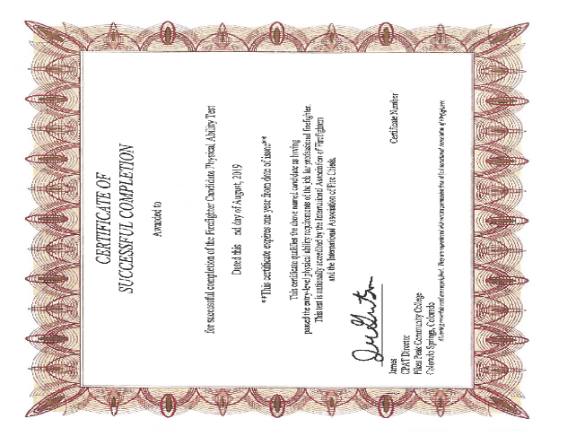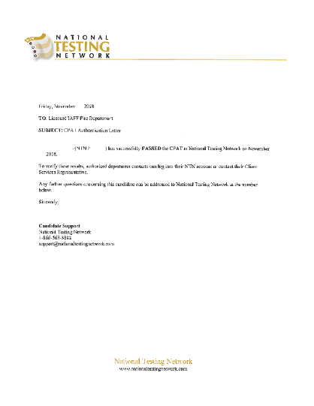
*When submitting your forms, you must submit them in the following format: last name_first name_form title. (Example: Smith_John_CPAT).

1. Upload ALL documents separately

2. To submit “CPAT certificates” click on: “Upload”.

CPAT Test Site Information
International Association of Fire Fighters, http://www.iaff.org/hs/well/statelist.htm
Pikes Peak Community College, WWW.PPCC.EDU/CPAT or call (719) 502-2000
PPCC CPAT Schedule, https://www.ppcc.edu/degrees-certificates/fire-science-technology/cpat
Aims Community College (NTN), https://www.aims.edu/academics/fire-science/cpat/
California Professional Firefighters, http://www.cffjac.org/go/jac/cpat/
Emergency Services Education Center, https://esec.wayne.k12.in.us/
Hutchinson Community College, http://www.hutchcc.edu/

3. EMT–Basic certificate or EMT-Paramedic
- Candidates testing for the position of Entry Level Firefighter must have a current National Registry EMT- Basic card, or a Colorado EMT–Basic certification card, and a valid CPR card.

- Candidates testing for the position of Entry Level Firefighter Paramedic must have a National Registry EMT-Paramedic or a Colorado EMT–Paramedic certification card, and a valid CPR, PALS, and ACLS card.

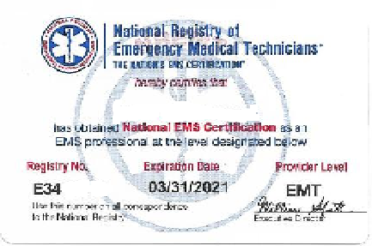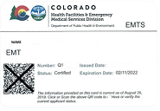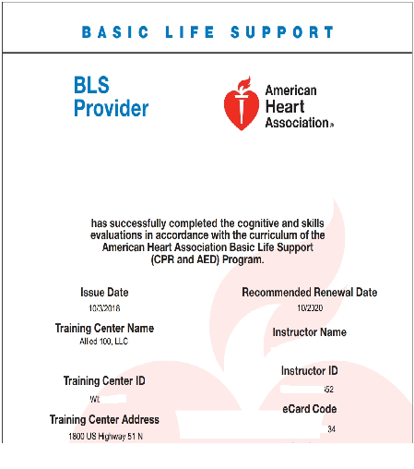

*When submitting your certificates, you must submit them in the following format: last name_first name_form title. (Example: Smith_John_NREMT_Card or CO_EMT_Card). Certificates must be submitted by the posted hiring deadline of August 31, XXXX at 11:59 p.m.

- Upload ALL documents separately

- To submit “National Registry Card or Colorado EMT Card” click on: “Upload”.

Colorado Out-of-State EMT Request
All Out-Of-State Applicants will be required to apply for a Colorado EMT once they receive a final offer of employment. Please use this link to get started: cdphe.emtcert@state.co.us

For more information or questions, please call: 303-691-4932

Colorado EMT and Paramedic Information
UCHealth, https://www.uchealth.org/events/events/education-and-training/ems-training-and-education

Centura Health's Penrose-St Francis Hospital, https://www.centura.org/education-and-training/ems-training-and-education

Penrose-St. Francis EMS Institute, https://www.centura.org/Education-and-Training/EMS-Training-and-Education/Southern-Colorado-EMS-Education

*The NREMT or State EMT is valid for 2 years

4. Veteran’s Preference:
To be eligible for Veteran’s Preference Points, you must have served on active duty with a branch of the Armed Forces of the United States. Applicants must have been discharged or released from active duty under honorable conditions, have received an Honorable Discharge ONLY and submitted the following documents for 10 or 5 points.

Download: Veterans Preference Points Form

Claiming ten (10) points:
1. Submit the Member 4 copy of your DD214.
2. Submit the Veterans Disabilities Rating Letter that shows your disabilities percentage.
3. Submit the CSFD Veteran’s Preference form to the CSFD Human Resources office.

Claiming five (5) points:
1. Submit the Member 4 copy of your DD214.
2. Submit the CSFD Veteran’s Preference form to the CSFD Human Resources office.

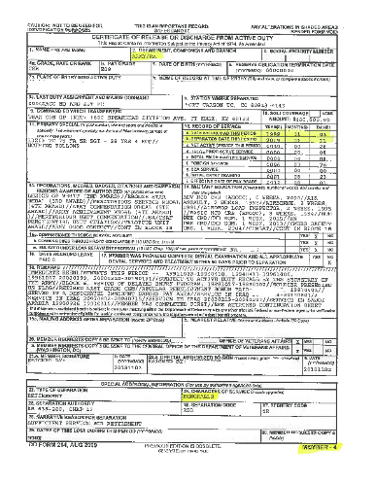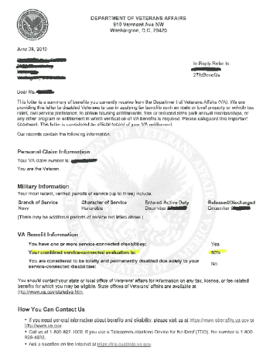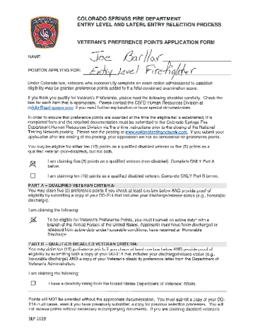

*All forms must be submitted to the CSFD Human Resources office by no later than AUGUST 31, XXXX prior to 11:59 p.m, using the following format: Last name_First name_form title.

- (Example: Smith_John_Veteran’s Preference Form). Forms are successfully submitted once a file shows uploaded.

1. Upload ALL documents separately

2. To submit all “Veterans Preference Points documents” click on: “Upload”.

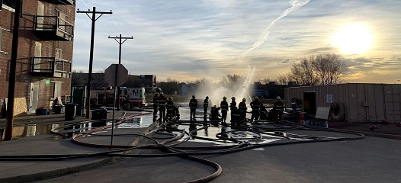

FIREFIGHTER SELECTION & APPOINTMENTS
(Subject to change)
- Notification of upcoming selection process and minimum qualifications will be posted on the CSFD website and NTN website. The deadline for submitting minimum qualifications is typically August 31 before the academy year, but may vary based on business need.
- FireTEAM test scores are submitted to CSFD and placed in to “selection bands.”
- Candidates notified of banding placement by CSFD. Top band will be invited to complete CSFD application and to schedule an interview.
- Based on performance during interview, top candidates may receive a Conditional Offer of employment and will be required to complete pre-employment/background check process.*
- A conditional offer does not guarantee a final offer.
- Final offers of employment will be issued based on results of pre-employment and background check process.
- Candidates not hired, but wish to apply again for future openings should monitor CSFD’s webpage for information or contact our recruiter. Past applicants must resubmit all updated test and certification information as outlined in this guide.

* Pre-employment and Background Check processes consist of the following:
- Interview
- Polygraph examination and background investigation
- Medical examination and drug screen
- Psychological evaluations

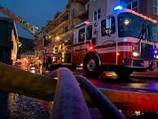

CSFD TRAINING ACADEMY
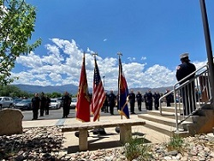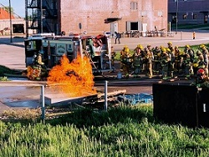

Entry-level trainees go through the CSFD Training Academy. Our Training Academies are designed to meet the National Fire Protection Association (NFPA) standard 1001. Academy graduates receive the following Pro Board Certifications: Hazardous Materials Operations, Firefighter I and Firefighter II. They will also receive National Wildfire Coordinating Group (NWCG) Wildland Firefighter Red Card.
Upon successful completion of your one year probationary period as a Firefighter Fourth Class, you will automatically progress to Firefighter Third Class and upon the successful completion of one year as a Firefighter Third Class, you will automatically progress to Firefighter Second Class. In order to progress to Firefighter First Class, you will be required to complete one of the following requirements:

- Successfully complete additional training/certification to obtain Certified Relief Driver status for pumper apparatus.
- Successfully complete the CSFD Paramedic Preparatory Course, completing all required classes to prepare to attend paramedic school.
- Successfully complete ten (10) years of experience as a Firefighter

SPECIALIZED TRAINING

- FIREFIGHTER SURVIVAL AND RESCUE SKILLS
- LIVE FIRE COMPANY DRILLS
- RELIEF DRIVER TRAINING

TRAINING ACADEMY RULES
- SAFETY
- FOLLOWING CHAIN OF COMMAND
- PROFESSIONAL APPEARANCE
- COMPLETION OF ASSIGNED TASKS
- UNIFORM INSPECTIONS
- CALM AND COMPOSED IN EXTREME SITUATIONS
- QUICK AND FLEXIBLE THINKING
- BEING PHYSICALLY AND MENTALLY FIT

2020-2021 FIRE DEPARTMENT SALARIES

TITLE | MONTHLY | ANNUAL
40 Hour/Week  Fire Trainee  56 Hour/Week | $4,550 | $54,600
Firefighter 4th Class | $5,039 | $60,468
Firefighter 3rd Class | $5,598 | $67,176
Firefighter 2nd Class | $6,220 | $74,640
Firefighter 1st Class | $6,857 | $82,284
Fire Driver Engineer  Fire Paramedic 3rd Class  Fire Paramedic 2nd Class | $7,431  $6,339  $7,043 | $89,171  $76,068  $84,516
Fire Paramedic 1st Class | $7,802 | $93,624

BENEFITS

Pension Plan Deferred Compensation
Basic Life Insurance Injury Leave / Worker’s Compensation
Medical Care Plans Employee Assistance Program (EAP)
Dental Plans Longevity Pay
Vision Plans Vacation
Short Term Disability Sick Leave
Long Term Disability Funeral Leave
Long Term Care Insurance Uniforms and Special Equipment
Voluntary Term Life Insurance Educational Assistance
Health Care Spending Account

CSFD FACILITY LOCATIONS

Fire Department Complex
375 Printers Parkway 80910
Fire Headquarters
Fire Training
Fire Community Education
Office of the Fire Marshal
Fire Museum

Station 1 29 S. Weber St. 80903
Station 2 314 E. San Miguel St. 80903
Station 3 922 W. Colorado Ave. 80905
Station 4 2280 Southgate Rd. 80906
Station 5 2830 W. Colorado Ave. 80904
Station 6 2430 N. Union Bd. 80909
Station 7 3901 Palmer Park Bd. 80909
Station 8 3602 Airport Rd. 80910
Station 9 622 W. Garden of the Gods Rd. 80907
Station 10 3730 Meadowland Bd. 80917
Station 11 3810 Jet Wing Dr. 80916
Station 12 445 W. Rockrimmon Bd. 80919
Station 13 1475 Cresta Rd. 80906
Station 14 1875 Dublin Bd. 80918
Station 15 4770 Scarlet Dr. 80920
Station 16 4980 Farthing Way 80906
Station 17 3750 Tutt Bd. 80922
Station 18 6830 Hadler View 80919
Station 19 2490 Research Pkwy. 80920
Station 20 6755 Rangewood Dr. 80918
Station 21 7320 Dublin Blvd. 80923
Station 22 711 Copper Center Pkwy. 80921
Station 23 TBD

CSFD INFORMATION
Inquiries concerning the firefighter selection process may be directed to:

The CSFD Human Resources Office
(Located in the Fire Department Complex)
375 Printers Parkway
Colorado Springs, CO 80910

Contact the
Before-CSFD Deadline contact
Human Resources Recruiter, (719) 385-7226

After-CSFD deadline contact
Human Resources Senior Analyst, (719) 385-7244

For further information.
You may also visit our website at www.coloradosprings.gov/firejobs

∼ We are an equal opportunity affirmative action employer ∼

